**Ex.No: 4 SIMULATE UNIX COMMANDS**

**Date : 12.03.2021**

**Aim**

To simulate unix commands.

**1. Write a C program to simulate “ls” command.**

**Algorithm:**

**1.** Start

**2.** Create a file using vi command with filename.c

**3**. Include the header files <stdio.h> for I/O operations, <stdlib.h> to call exit() , <sys/types.h> and <dirent.h>

**4**. Get the directory name in the name of curr_dir

**5**. If the value of curr_dir is NULL, print the error statement.

**6**. Then using opendir() try to open the directory in curr_dir

**7**. If the value of dp is NULL, print the error statement.

**8**. Otherwise, it will print the list of files and directories .

**9.** Stop.

**Program:**

#include <stdio.h>

#include <stdlib.h>

#include <sys/types.h>

#include <dirent.h>

void main()

{

char *curr_dir = NULL;

DIR *dp = NULL;

struct dirent *dptr = NULL;

int count = 0;

curr_dir = getenv ("PWD");

if(curr_dir == NULL)

{

printf("\n ERROR : Could not get the working directory\n");

exit(-1);

}

dp = opendir((const char*)curr_dir);

if(dp == NULL)

{

printf("\n ERROR : Could not open the working directory\n");

exit(-1);

}

printf("\n");

for(count = 0; (dptr = readdir(dp)) != NULL; count++)

{

printf("%s \n",dptr->d_name);

}

printf("\n %d", count);

}

**Sample Output:**

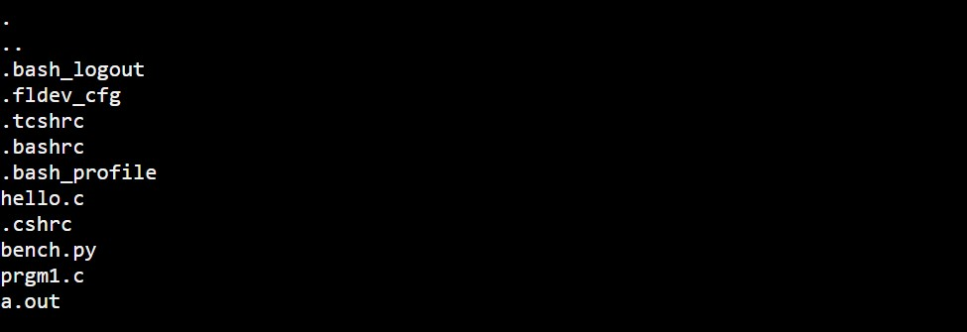

**2. Write a C program to simulate “grep” command.**

**Algorithm:**

**1.** Start

**2.** Create a file using vi command with filename.c

**3**. Include the header files <stdio.h> for I/O operations and <string.h>

**4**. Declare a file pointer and try to open the file and write on it.

**5**. Then enter the contents of the file and end it with $.

**6**. Then enter the pattern to be searched.

**7**. If the pattern is found, it will be displayed otherwise not.

**8.** Stop.

**Program:**

#include<stdio.h>

#include<string.h>

void main()

{

FILE *fptr;

char ch;

int i;

char p[10], a[50];

fptr=fopen("input.txt","w");

printf("Enter the data to be stored in the file\n");

scanf("%c",&ch);

while(ch!='$')

{

fprintf(fptr,"%c",ch);

scanf("%c",&ch);

}

fclose(fptr);

printf("Enter the pattern to be searched\n");

scanf("%s",p);

fptr=fopen("input.txt","r");

i=0;

while(!feof(fptr))

{

ch=getc(fptr);

if( ch!='\n')

a[i] = ch;

else

{

a[i]='\0';

if(strncmp(a,p,strlen(p))==0)

printf("%s\n",a);

i=-1;

}

i++;

}

fclose(fptr);

}

**Sample Output:**

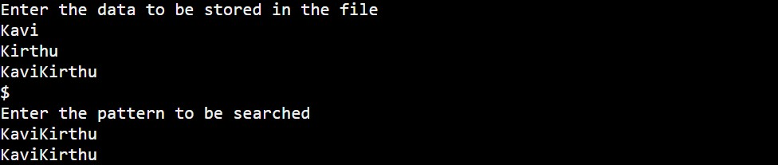

**3. Write a C program to simulate “cp” command.**

**Algorithm:**

**1.** Start

**2.** Create a file using vi command with filename.c

**3**. Include the header files <stdio.h> for I/O operations, <stdlib.h> to call exit() and <fcntl.h> and <sys/stat.h>

**4**. At first, it’ll display some statements.

**5**. Then it’ll try to open the source file from where the contents have to be copied.

**6**. If the file is empty, error statement will be printed.

**7**. Then it’ll try to create the destination file from where the contents have to be pasted.

**8**. Then the source file is read and the contents are written into the destination file.

**9**. Thus the source file is copied to destination file.

**10.** Stop.

**Program:**

#include <stdio.h>

#include <stdlib.h>

#include <fcntl.h>

#include <sys/stat.h>

#define SIZE 1024

main(int argc, char *argv[])

{

int src, dst, nread;

char buf[SIZE];

if (argc != 3)

{

printf("Usage: cc copy.c \n");

printf("Usage: ./a.out <filename> <newfile> \n");

exit(-1);

}

if ((src = open(argv[1], O_RDONLY)) == -1)

{

perror(argv[1]);

exit(-1);

}

if ((dst = create(argv[2], 0644)) == -1)

{

perror(argv[1]);

exit(-1);

}

while ((nread = read(src, buf, SIZE)) > 0)

{

if (write(dst, buf, nread) == -1)

{

printf("can't write\n");

exit(-1);

}

}

close(src);

close(dst);

}

**Sample Output:**

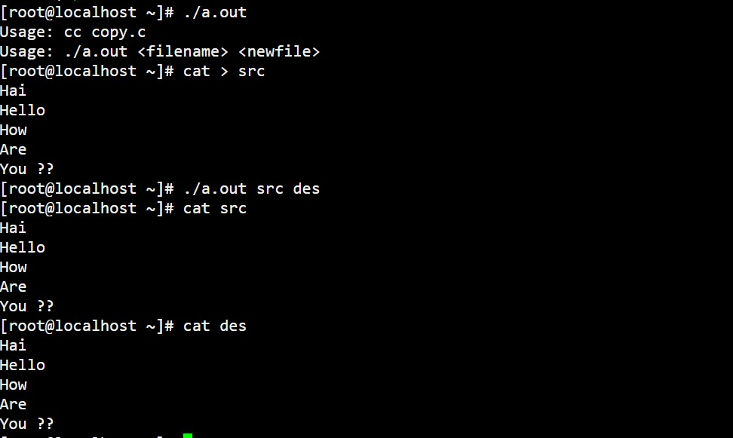

**4. Write a C program to simulate “rm” command.**

**Algorithm:**

**1.** Start

**2.** Create a file using vi command with filename.c

**3**. Include the header files <stdio.h> for I/O operations, <stdlib.h> to call exit() and <fcntl.c>

**4**. It tries to find the file name given.

**5**. Then it unlinks the file from our directory.

**6**. Thus the file is removed.

**7.** Stop.

**Program:**

#include <stdio.h>

#include <stdlib.h>

#include <fcntl.h>

void main(int argc, char* argv[])

{

int fd;

if (argc != 2)

{

printf("Usage: cc del.c\n");

printf("Usage: ./a.out <filename>\n");

exit(-1);

}

fd = open(argv[1], O_RDONLY);

if (fd != -1)

{

close(fd);

unlink(argv[1]);

}

else

perror(argv[1]);

}

**Sample Output:**

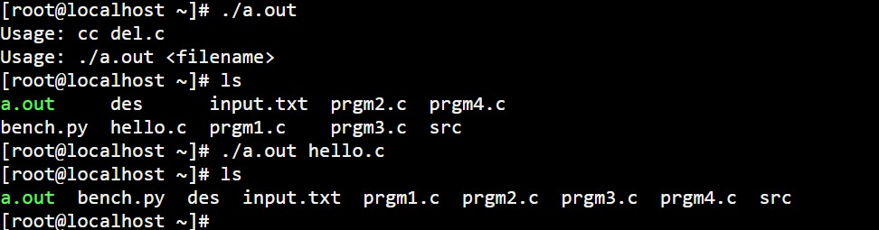

|  |  |
| --- | --- |
| **Observation(20)** |  |
| **Record(5)** |  |
| **Total(25)** |  |
| **Initial** |  |

**Result:**

Thus the unix commands are included in the programs and are simulated successfully.